**A**

**MANUAL FOR PREPARATION OF**

**SOFTWARE REQUIREMENT SPECIFICATION**

**FOR  
NON SYLLABUS PROJECT**

(Academic Year 2017-18)



**POORNIMA INSTITUTE OF ENGINEERING & TECHNOLOGY, JAIPUR**

**S.No. Topic**

1. Purpose
2. Scope
3. Product Perspective
4. E-Commerce workflow Diagram
5. Product Functions
6. User Characteristics
7. Specific Requirements
8. Non Functional Requirements
9. Functional Requirements
10. Appendix – 1 (Front Cover of the Report – Specimen Copy)
11. Appendix – 2 (Title Page of the Report – Specimen Copy)
12. Appendix – 3 (Certificate – Specimen Copy)
13. Appendix – 4 (Acknowledgement – Specimen Copy)

# 

# 1. Purpose

* The purpose of this document is to introduce the non functional requirements of the “OMX SHOP”.
* The purpose of the project is to develop a web application to ease the process of purchasing fashion and grocery items by facilitating the purchase online. Through a Web browser, a user can browse a catalogue, place items to purchase into a virtual shopping cart, create and sign in to a user account, and purchase the shopping cart contents by placing an order with a credit card/debit card/paytm/cash on delivery. we provide the best security to user.
* The target audience is the Ladies/Girls “OMX SHOP” as we provide Grocery and Fashion items which attract them to visit and we provide better user interface.

**2. SCOPE**

Description of the scope of the software under consideration by:

* The software system being produced is called E-Commerce System or OMX SHOP. It is being produced for a seller interested in selling fashion and grocery items via the Internet. This system is designed to “provide automation support” for the process of placing items for sale on the Internet and facilitating the actual sale. This system is largely cross-platform and is available to anyone that has to be interested in fashion and grocery store. The system will be run on a central server with each user having a remote user interface through a web browser to interact with it.
* The E-Commerce System (OMX SHOP) will allow any user to create an account to become a customer. The customer, through the process of account creation, will have the option to become a member of the site. The system will allow customers to browse, search, select, and add items to a shopping cart. Then, provided they have items in their shopping cart, check out items in shopping cart and decrement the stock that the inventory the system maintains. The OMX SHOP also allows a manager to manage the inventory with full create, retrieve, update and delete (CRUD) functionality with regards to items in the system. It will also allow, on an inventory wide basis, customers and managers to interact with a promotion system that handles percentage-off promotions that can be applied to member’s orders. This interaction includes the creation (by managers) and the application to orders (by customers) of the promotions. The OMX SHOP has full email capabilities; the automated email functionality will be used to send promotions to members of the system as well as provide the managers with low-stock notifications.
* The OMX SHOP will have numerous constraints on what it can do. The system will not have full credit-card processing capabilities. It will not allow managers to be customers. The manager will be a hard-coded user and only a single manager will exist.However the system will provide the customer with a receipt and it will log the transaction details. The system will not allow multiple promotions to be added to a single shopping cart nor will it allow a customer to add more than one of each item to their cart. The system also will not allow users to retrieve passwords or edit their user details.

Partial example: The “OMX SHOP” is a e-commerce-based website, which helps people to find the fashion and grocery items at lowest price based on the user’s requirement. Users track theordered item on a map and get navigation to them.  
Seller provide the product information using the web-portal.  
An administrator of the web-portal verifies Sellers and manages user information.

**3. PRODUCT PERSPECTIVE**

OMX SHOP is an online fashion and grocery website which supports a number of functions for both the consumer and store's management. A block diagram showing the major elements of the larger system, interconnections, and external interfaces can be helpful.

The workflow diagram shows the flow chart of our E-Commerce website.

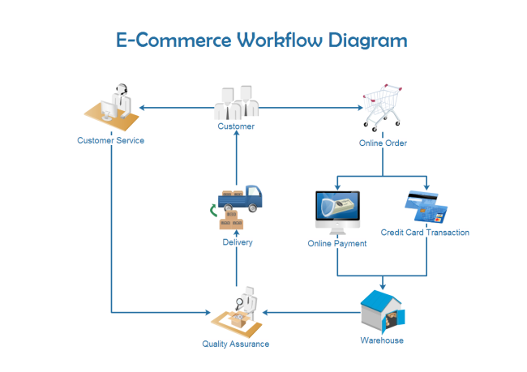

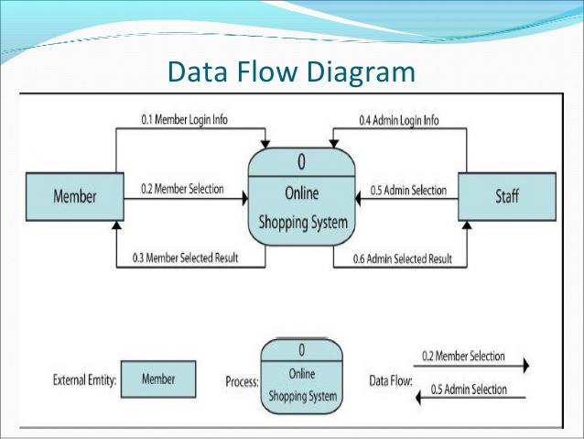

Figure 1. Block diagram. Source: cse.chalmers.se

**3.1. SYSTEM INTERFACES**

List each system interface and identify the functionality of the software to accomplish the system requirement and the interface description to match the system.

**3.2. USER INTERFACES**

* **User able to see product details without login or sign up.**
* **Screen size is min. 300px *8500px to max.**
* **Website should be responsive.**
* **Contents are :**
* **Categories**
* **Shopping cart**
* **Checkout**



**3.3. HARDWARE INTERFACES**

* **Web Servers:** web servers can be refers to either the hardware or software that helps to deliver the content that can be accessed through internet. The most common use of web servers is to host web sites but there are other uses such as data storage or running enterprise application.

**4. PRODUCT FUNCTIONS**

OMX SHOP will provide a number of functions; each is listed below.

• Maintain data associated with the inventory

• A product has a brand, description and price

• The inventory also keep track of the stock/quantity of each product.

• Maintain records for many customers

• A customer can be either a member or non-member.

• A customer has a username (unique across all users), password (no restrictions), email address (no restrictions), and postal address (unverified.)

• Anyone may sign up for a customer account.

• Allow any customer to become a member.

• Show a listing of availableproducts.

• Each product will list the following from left to right

• Brand

• Description

• Price

• Allow customers and managers to log in and out of the system.

• Users (both customers and the manager) will be logged out if inactive for 30 minutes.

• Shopping cart

• Anyone is able to add one or more products to the shopping cart.

• Checkout

• Checkout is only available to logged-in customers. A user that is not logged in as a customer is given a chance to log in.

• Member customers may enter a promotion code.

• Only one promotion code may be used per purchase .

• The promotion is a fixed percentage discount that is to be applied to an entire order.

• The discount is specified by the manager at the time of the promotion’s creation or most recent update/edit.

• Collect a 16-digit credit card number from the customer

• Log/record the transaction

• Allow manager to specify a stop-order for a products.

• When the quantity a products falls below a threshold, the manager is notified that to order more products to the seller.

• One exception is if the manager has already specified a stop-order for this products.

• Every product must either have stop-order enabled or disabled

• Allow manager to update stock quantities

• Allow manager to change any product’s price

• Allow manager to view transaction logs

• Allow manager to create promotions

• A promotion is a percentage discount that can be applied to an entire order

• Promotions may only be used by member customers

• A promotion has an expiration date specified by the manager When a promotion is created, it is emailed to all member customers via the email address on record

**5. USER CHARACTERISTICS**

The typical website user is simply anyone that has access to the Internet and a web browser in the in jaipur. It is assumed that the user is familiar enough with a computer to operate the browser, keyboard and mouse and is capable of browsing to, from and within simple websites.

**6. SPECIFIC REQUIREMENTS**

1. Restrictions

1.1.User Side 9

1.1.1.Software

1.1.1.1. Internet Explorer or Mozilla Firefox

1.1.2.Hardware

1.2. System Side

1.2.1.Software

1.2.1.1. Web-based application

1.2.1.2. Database information storage system

2. Data Structure

2.1.Product has these attributes

2.1.1.Unique ID (auto-increment starting at 1)

2.1.2.brand

2.1.3.Description

2.1.4.Price

2.1.5.Reorder Threshold

2.1.6.Stop-order Boolean value

2.1.7.Stock

2.2.Customer has these attributes

2.2.1.Unique Username

2.2.2.Password

2.2.3.Name

2.2.4.Email Address

2.2.5.Postal Address

2.2.6.Member/Not Member Boolean value

2.3.Manager has these attributes

2.3.1.Username

2.3.2.Password

2.3.3.Email address

2.4.Order log entries have these attributes:

2.4.1.Unique ID (auto generated)

2.4.2.Time transaction took place

2.4.3.Date transaction took place

2.4.4.Username of customer

2.4.5.Listing of the contents in customer’s shopping cart

3. System

3.1.Browse Inventory

3.1.1.Organization

3.1.1.1. Items Listed on single page

3.1.1.2. Items shown in tabular format

3.1.1.3. Each Item listing contains

3.1.1.3.1. Brand

3.1.1.3.2. description

3.1.1.3.3. Price

3.1.1.4. Listing sorted by Ascending item Title

3.1.1.5. No individual Item pages

3.1.2.Interaction

3.1.2.1. Each Item has checkbox to mark selection

3.1.2.2. Single button to add all selected items to Shopping Cart

3.2. Search Inventory

3.2.1.Search available only by brand

3.2.2.Search is exact-match only

3.3.Create, Update and Destroy (CRUD) Functionality

3.3.1.Only managers are allowed to modify inventory

3.3.2.Managers have an interface to:

3.3.2.1. Create a product entry

3.3.2.2. Update a product entry

3.3.2.3. Update the stock/quantity of a particular product

3.3.2.4. Create a new promotion

3.3.2.5. Review current inventory

3.3.2.5.1. Using the same interface to browse inventory as described in

section 3.1, the manager has an additional “Edit Item” option for each

product.

3.3.2.5.1.1. Manager has full CRUD capabilities on each product.

3.3.3.Managers may delete items from the inventory

3.4. Shopping Cart

3.4.1.Logged In

3.4.1.1. Can add items to cart

3.4.1.1.1. If Item is not in stock, message displayed informing user to try

again later

3.4.1.1.2. Customer can only purchase one of each item (no quantities

associated with orders)

3.4.1.1.3.

3.4.1.2. If shopping cart not empty, a user may begin Checkout procedure

3.4.2.Not Logged In

3.4.2.1. Can add items to cart

3.4.2.2. User required to login before they may begin Checkout procedure

3.5.Checkout procedure

3.5.1.User must successfully use shopping cart before beginning this procedure

3.5.2.Checkout page consists of

3.5.2.1. A text box for promotion entering

3.5.2.2. An overview of the purchase

3.5.2.3. A text box to hold the credit card number

3.5.2.4. A button to complete the order

3.5.3.Order details sent via email after the checkout has completed

3.5.4.On order completion the inventory is decremented based on items purchased by

user

3.6.Authentication System

3.6.1.User Levels

3.6.1.1. Manager

3.6.1.2. Customer (unlimited, open creation, unlimited orders)

3.6.2.Account Creation

3.6.2.1. Everyone is allowed to create an account

3.6.2.2. Required Information

3.6.3.Account Modification

3.6.3.1. Users are not able to modify any aspect of their account after creation

3.6.4.Login and Logout

3.6.4.1. There is no lost-password recovery

3.6.4.2. Logging in allows one to logout

3.6.4.3. Logging in allows checkout

3.6.4.4. There is a 30-minute session time out after which a logged in user will be

logged out automatically.

3.7. Promotions

3.7.1.Specifications

3.7.1.1. Applies to entire order

3.7.1.2. Percentage-off type promotion (x% off entire order)

3.7.1.3. Expiration occurs at manager specified date

3.7.1.4. Multiple coupons cannot be applied to same order

3.7.1.5. Non-member users cannot apply promotions to order

3.7.2. Creation

3.7.2.1. Promotion created by manager

3.7.2.2. Each promotion has a unique identifying number (can be auto generated)

3.7.2.3. Email containing promotion sent to all member users of the

System

3.7.2.4.

3.7.3. Deletion

3.7.3.1. Promotions are auto-deleted when the expiration date has passed

3.8. Automated Reorder

3.8.1. Specifications

3.8.1.1. Manager sets reorder threshold on a per-item basis

3.8.1.2. If item reaches the reorder threshold, an email is sent informing the

manager of the item’s status and the system automatically reorders the item

3.8.1.2.1. If the item has a stop-order applied to it, it will not automatically

reorder until the manager removes it.

3.8.1.3. A manager may increase the stock of an item using the manager’s

account

3.9.Order Logging

3.9.1.Specifications

3.9.1.1. Required Information:

3.9.1.2. A manager can view all past transactions from all users

# 8. Non-Functional Requirements

# Performance Requirements

* Fast to load website which should not take more than 4 seconds to load.
* The application should be able to support 500 users without any performance any Lag.
* Although striving to have a 100% uptime, unless during a scheduled maintenance period

The system should be able to scale up to 500 concurrent users (if there is a need in the future) by installing additional hardware components.

### Availability Requirements

* The system has to be online 24 hours a day, 7 days a week and can be excess all over the city.

### Security Requirements

* There are 3 roles ‘Developer’, 'customer’ and 'administrator'. Each person that goes to the system's website will be required to register if they want to do more than just read / browse site content.
* A secure server will be required to ensure confidentiality of customer’s credit card and other details
* Administrator have all the power to delete fake users or block fake users.
* Best security server will be required as there will be lot of personal data of user.

### Usability

* The user interface of the system should be very user friendly.
* Lot of offers for Users to attract people.
* It should not take more than 120 seconds for a new user to register for an account.
* It should not take more than 90 seconds for a registered user to place an order.

### Design

* Python and allied web technologies should be used for development of the website.
* Html and CSS for Front-end.
* PHP should be used as the database.

### Legal

* All the images used on the site must be procured through legal channels and there should be no copyright violations.

### Maintainability Requirements

* The system should be developed in such a way that changes can be made easily, whether for bug fixes or to add new functionality.
* The system should be easy enough to maintain that someone else could do it with a manual and a few hours training.

### Portability Requirements

* The system should be portable to various operating environments.
* Should the current hosting become too restricting for the system, the system must be portable enough to be moved over to a new server with minimal downtime.

### Manageability Requirements

* The system should be developed in such a way that it can be easily reused, deployed and tested.

### Organizational Requirements

* Business and political factors such as cost – benefit and partnership with a vendor should be taken care of.

### Schedule

* The entire system should be up and running in the user’s production environment by 15 Nov 2018.

**9.Functional Requirements:**

**User End:**

* User have to able to see products and able to check cost without create an account. Easy to update site content, add products, remove products, edit products
* It needs a smooth checkout flow.
* Search function for the website.(Search Engine optimization.)
* Live tracking of costumer order.
* Catalog: List of fashion and grocery items which are available for sale
* Products: List of available Fashion and Grocery items.
* Analytics measurement on the website (e.g. Google Analytics)
* Should be able to add video to the website.
* Sharing: Products which are available can easily share to contacts via messages.
* Checkout: Order placement and payment procedure through COD/Paytm/Credit Card.
* Website Forms

         Contact us form

         Online Enquiry Form

 Feedback form

Login form

Sign in form

Checkout form

Payment gateway  
 Catalogue Form

**Admin end:**

* Manage all orders.
* Manage all the data of the users and Visitors.
* Able to delete fake Account.
* Listing of products in website.
* Manage all the security and payment gateway.
* Provide live tracking of orders to the costumers (GPS Tracking Software).
* Manage pricing and inventory of products.

.

**SOFTWARE REQUIREMENT SPECIFICATION**

**FOR**

**NON SYLLABUS PROJECT**

**DEVELOPMENT OF AN E-COMMERCE WEBSITE**

Submitted in partial fulfillment of the degree of Bachelor of Technology

Rajasthan Technical University



By

**Harsh Goyal (CS/17/039)**

**Hemant Jain (CS/17/042)**

DEPARTMENT OF COMPUTER ENGINEERING

POORNIMA INSTITUTE OF ENGINEERING & TECHNOLOGY, JAIPUR

(Academic Year 2018-2019)

|  |  |
| --- | --- |
|  | **RAJASTHAN TECHNICAL UNIVERSITY**  **POORNIMA INSTITUTE OF ENGINEERING & TECHNOLOGY, JAIPUR** |

**CERTIFICATE**

This is to certify that SRS for Non Syllabus Project entitled “**DEVELOPMENT OF A E-COMMERCE WEBSITE - OMX SHOP** ” has been submitted by “Hemant Jain (PIET/17/CS/042), Harsh Goyal (PIET/17/CS/039)” for partial fulfillment of the Degree of Bachelor of Technology of Rajasthan Technical University. It is found satisfactory and approved for submission.

Date: 31 Oct'2018

Mr./Ms. <Guide Name> Mr./Ms. <HOD Name> Mr.

PRODUCT OWNER Head, Director,

<Designation>, Computer Science PIET, Jaipur

<Department> PIET, Jaipur

PIET, Jaipur

**ACKNOWLEDGEMENT**

A project of such a vast coverage cannot be realized without help from numerous sources and people in the organization. We are thankful to **Mr. Shashikant Singhi, Director General, PGC** and **Dr.OmPrakash , Director, PIET** for providing us a platform to carry out such huge projects successfully.

We are also very grateful to **Mr. Deepak Moud, HOD (CE)**for their kind support.

We like to take this opportunity to show our gratitude towards **Mr. Ravindra and Mr. Sandeep Tuli, NSP Coordinator (CE)** who helped us in successful completion of our SRS. They have been a guide, motivator & source of inspiration for us to carry out the necessary proceedings for the project to be completed successfully.

We are also grateful to the **department** for guidance and support.

We are thankful to **MR. Sandeep Tuli** for his kind support and providing us expertise of the domain to develop the project.

We are also privileged to have **Mr.Ravindra** who have flourished us with his/her/their valuable facilities without which this work cannot be completed.

We would also like to express our hearts felt appreciation to all of our friends whom direct or indirect suggestions help us to develop this project and to entire team members for their valuable suggestions.

Lastly, thanks to all faculty members of Computer Engineering department for their moral support and guidance.

Submitted by:

**Team Members:**

**Hemant Jain**

**Harsh Goyal**